Welcome!
Date
Name
Spouse
Address
City
State Zip _________
Email

Please Contact By
❑ Card  Phone  Visit

Telephone Best Time to Call
Home ______________
Work ______________

Guest: First Time Second Time
Are you a church member: yes no
Church
City, State

Circle Appropriate Age/Grade Group(s)
Preschool: Ages: B-1 2-3 4-5
Children: Grades: K 1 2 3 4 5 6
Youth: Grades: 7 8 9 10 11 12
Adults: Ages:18-29 30s 40s 50s 60s+

How did you learn about our church?
Newspaper Friend Yellow Pages Mail
Other

I am a guest of:

New in the Community? Yes No
Names & ages of children at home

Weekly Service & Activity Schedule

April 27, 2014
9:45 a.m. Sunday School
11 a.m. Morning Worship

6:00 p.m. Sam Craig

Week of April 28 – May 3
Wednesday, 6:30 p.m. Youth Activities
Wednesday, 6:45 p.m. Adult Prayer & Bible Study


Upcoming Events
April
27 Musicians and Church Staff Appreciation Day
27 Sam Craig

Birthday & Anniversary Recognitions will occur on the final Sunday of each month.

Graduation Banquet - If you graduated in December, or will graduate in June 2014, please let Geneva Davis or Otisann McManus know so you can be recognized at the upcoming Graduation Banquet.

Knobbs Springs Baptist Church

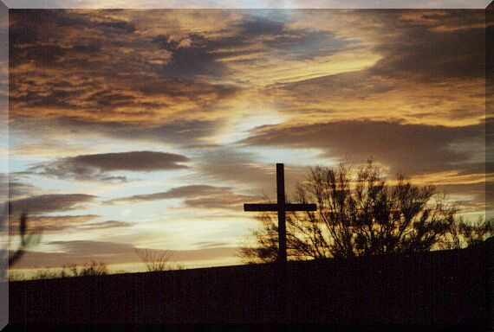

I thank my God every time I remember you. In all my
prayers for all of you, I always pray with joy
because of your partnership in the gospel from
the first day until now, being confident of this,
that he who began a good work in you will carry it on
to completion until the day of Christ Jesus.

It is right for me to feel this way about all of you, since I
have you in my heart and, whether I am in chains
or defending and confirming the gospel,
all of you share in God’s grace with me. God can
testify how I long for all of you with the affection of
Christ Jesus. Philippians 1:3-8

April 27, 2014

Church Information:
KnobbsSpringsBC.com KnobbsSpringsBaptist@gmail.com
1662 CR 305, McDade, Texas 78650 512-273-2743
Brother Dwight Reagan 512-247-6448
Kimberly Tabor, Office Manager 512-698-2804

